The APRON is the part of the stage which projects beyond the proscenium into the auditorium.
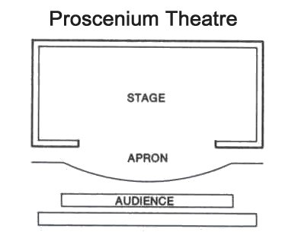

An ARBOR is a carriage or rack that contains weights in sufficient quantity to balance a load.
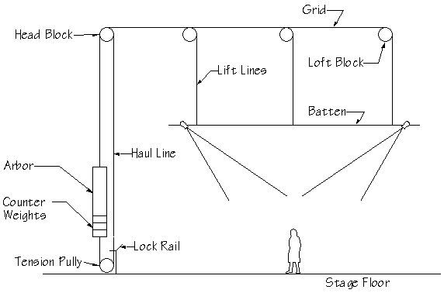
A BATTEN is a bar, usually made from steel pipe, from which scenery, lights and curtains are hung.

A BOOM is a vertically oriented pipe. It is most often used to mount stage lights (usually for side lighting).

A BORDER is narrow horizontal masking piece (hard or made of cloth) used to mask lighting instruments and flown scenery from the audience; also to provide an upper limit to the scene. The term is often used in conjunction with LEGS.

A CYCLORAMA (or, cyc) is a plain white drop at the rear of the stage that can be lit to represent various times of day, seasons, and weather conditions. Images can also be projected onto the cyclorama surface to produce effects, such as clouds or stars.
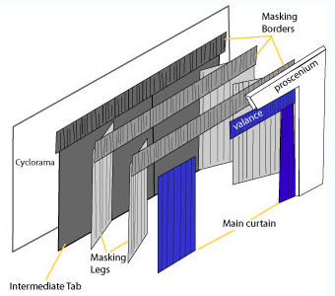

DEAD HUNG means that something cannot be flown in or out – its elevation is fixed.

DUTCHMAN is tape or material used to cover (and mask) the seams between flats, or to cover hinges, prior to painting.

A FLAT is a lightweight timber frame covered with scenic canvas, or MUSLIN. Might also be covered with plywood or hardboard and, consequently, not so lightweight. Many theatres have a range of flats in stock built to standard sizes which are re-used many times.
RAIL – a horizontal batten within a flat. (SILL – alternate name for the bottom rail of a flat.)
STILE – a side or vertical piece within a flat.
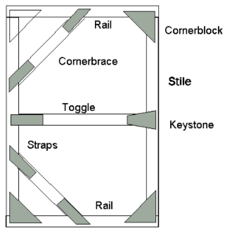
To FLY is the act of lifting or lowering scenery, lights, curtains, or even people. When something is being lowered to the stage deck, it is “flying in.” When something is being lifted, it is “flying out.”

FRONT OF HOUSE (FOH) is a generic term referring to the audience, lobby, and box office areas; any area (or job) not on stage or backstage.

GAFFER’S TAPE (or, GAFF TAPE) is a ubiquitous sticky cloth tape used for temporarily securing almost anything. Thinner gaff tape of various colors is used mainly for SPIKING. The name is derived from the electrician in charge of lighting on a film or TV set, who is also called a gaffer.
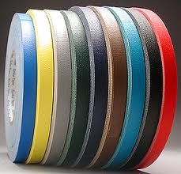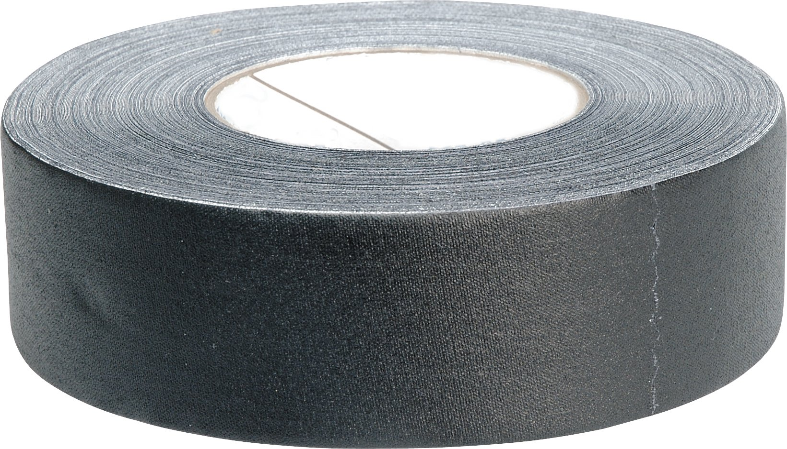

A GOBO is a thin metal plate etched with some design (like a stencil) which, when placed into a lighting instrument, projects patterned light (for example, trees/leaves, windows, etc.). The image can be used in soft focus to simply add texture, rather than a recognizable image. PATTERN and /or TEMPLATE can also refer to a gobo in some areas. [In the TV/Film industry, a Gobo is a piece of material used to mask or block light, and it can be used as a verb (e.g. 'We need to gobo off that light so the camera doesn't see it').]
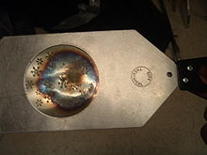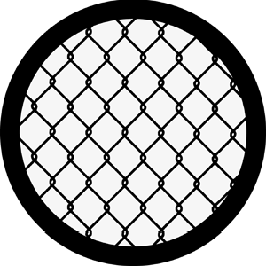

A GROUNDROW is:
- A long piece of scenery positioned at the base of a drop usually to mask the bottom of the drape or the instruments lighting it.

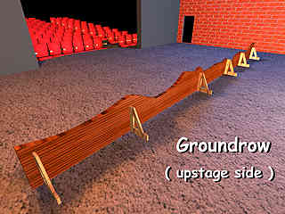
2) Compartmentalized floodlights (also called STRIP LIGHTS) at floor level used to light the cyclorama, etc.
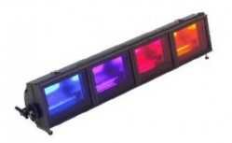

A LEG is a drape (or sometimes a FLAT) placed as a masking piece at the side of the acting area. Usually set up in pairs on either side of the stage, and used in conjunction with BORDERS, to frame the stage and mask the wings.

A LIFT LINE is any rope or cable located between a LOAD and a winch or COUNTERWEIGHT ARBOR.

A LINE SET is a system consisting of one or more lift lines and its related components (e.g., pulleys) operating together to lift, lower, or suspend a load.

The PROSCENIUM is the arch separating the stage from the auditorium, through which the action of a play is viewed (therefore, also known as the “proscenium arch”). In the ancient Greek theatre, the proscenium originally referred to a row of colonnades supporting a raised acting platform, and afterward, to the entire acting area. The proscenium creates a “picture frame” or an imaginary fourth wall through which the audience experiences the illusion of spying on characters behaving as if they were unobserved.

A “RAKED stage” means that the stage deck is on an incline, generally from higher elevation upstage to lower downstage.

A RETURN is a flat (or rather, that part of a flat) joined to the DS edge of another flat that “returns” into the wings. It helps mask backstage areas and also gives a clean, finished look to the set.

A SCRIM is a curtain made from a special material that appears opaque when lit from the front but becomes transparent when back lit.

To SPIKE is to mark the position of a set piece on stage or in the rehearsal room, usually with special tape referred to as SPIKE TAPE. Therefore, those marks are called SPIKE MARKS. Spike tape is normally thin gaff tape, and multiple colors are used to designate for which acts and/or scenes the spike marks are intended. Where precision is required during blackouts, GLOW TAPE is often used.
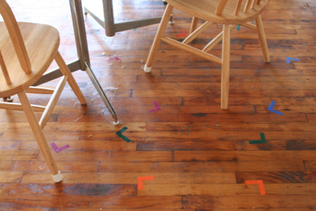

A TAB is a curtain/drape hung parallel to the playing space in order to more completely mask the wings (see image below).

The TEASER is the first border positioned behind the proscenium which, with the tormentors, forms an inner frame of the stage. It also masks lighting instruments and the various battens from which drops are hung. Sometimes referred to as a VALENCE.

TORMENTORS are the first set of legs behind the proscenium. They can be drapes or narrow masking flats. The name “tormentor” developed because they prevented people in the box seats from being able to see into the wings.
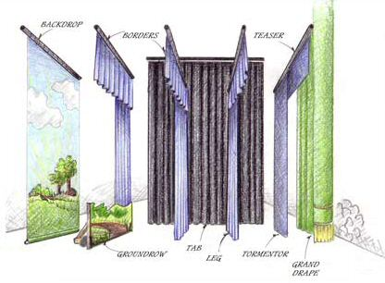
A TRAVELER is a curtain on a track that can be opened or closed to reveal or mask a portion of the stage. Just as sets and drops can “fly” in and out vertically, curtains and set pieces also “travel” in (onstage) and out (offstage).

TRIM means:
(1) A load is "in trim" when the equipment load equals the counterbalancing weight.
(2) A set piece or batten is trimmed when it has been placed in the desired position within the performance area.

A VOMITORIUM is the passageway in arena, three quarter, and thrust stages through which actors (and sometimes also the audience) make entrances and exits.
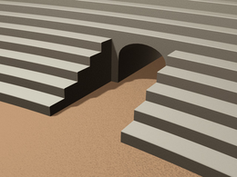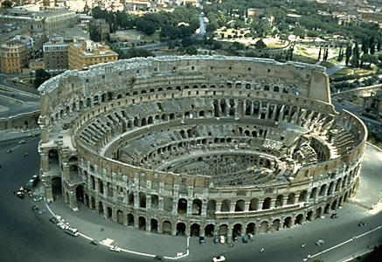
Note: Was a vomitorium really something in ancient Rome where people would go to vomit between courses in order to eat more?
No. A vomitorium (from the Latin root vomere, meaning “to spew out”) was a passageway in an amphitheater or theater that opened into a tier of seats from below or behind. For example, the vomitoria of the Colosseum in Rome were so well designed that it's said the immense venue, which seated at least 50,000, could fill in 15 minutes. (There were 80 entrances at ground level, 76 for ordinary spectators and 4 for the imperial family.) The vomitoria deposited mobs of people into their seats and afterward disgorged them with equal abruptness into the streets – from whence, presumably, the name. So, a vomitorium today is exactly the same thing as 2000 years ago.
The WINGS are that portion of the stage area located to either side of the acting area.

