Which type of molecule forms the cell membrane?
Phospholipids are molecules that are composed of:
The interior of the lipid bilayer of a cell membrane forms a nonpolar zone that allows most ________ molecules to pass through the membrane.

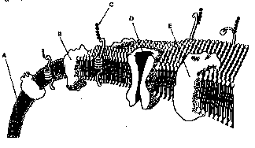
Refer to the illustration above. The structure labeled A is composed of

Proteins in the cell membrane that identify the cell are called
As a result of diffusion, the concentration of many types of substances 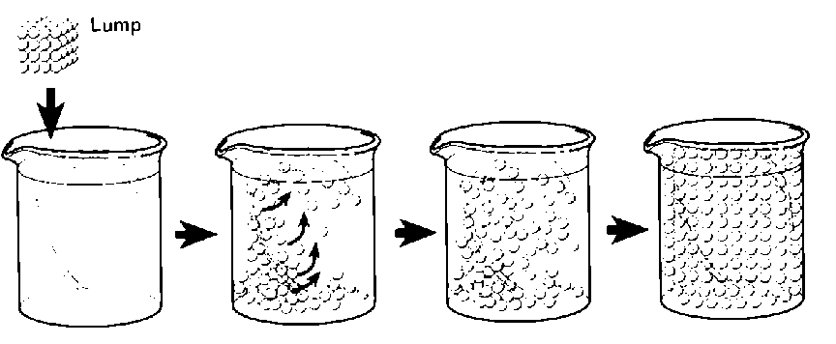
What does the above figure represent?
Diffusion is the movement of a substance from an area of ______ concentration to an area of ________ concentration
Proteins that serve as tunnels for specific substances through the lipid bilayer are ________________

Sugar molecules cross the cell membrane by ___________________

Which types of transport do(es) not require energy?

The diffusion of water into or out of a cell is called

Osmosis is a type of ________________transport

How does water pass through the cell membrane?

Where are the areas of high and low concentration in an isotonic solution

Unlike passive transport, active transport _____________________________________

Name two forms of active transport?

The sodium-potassium pump

Molecules that are too large to be moved across a cell membrane can be removed from the cell by

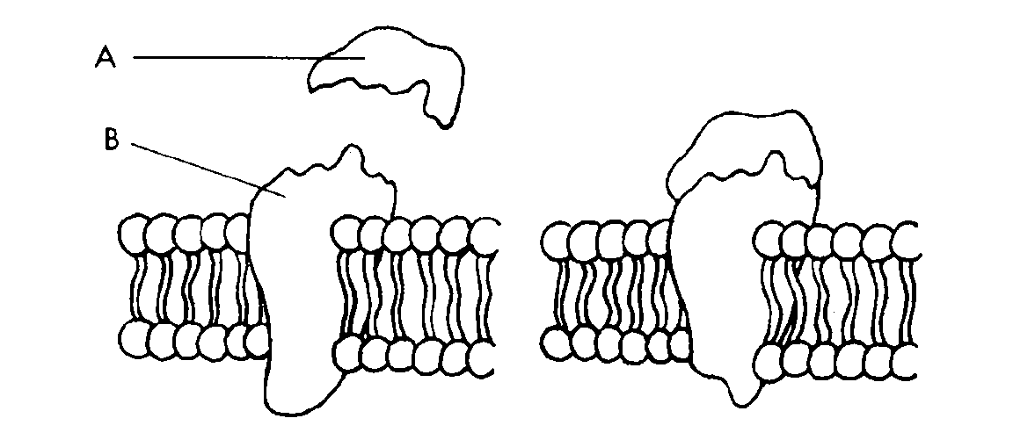
Signal molecules bind to

