Title: ch 1……..
Purpose: The purpose of this lab is to construct graphs of hypothesis using data obtained from our class and other classes.
· Taller people can jump higher.
· Older people weigh more.
· Etc
Background: independent variable, dependent, line graphs, other types of graphs, experimental data- were numbers accurate- why or why not?, what is a hypothesis as opposed to a theory

Data:
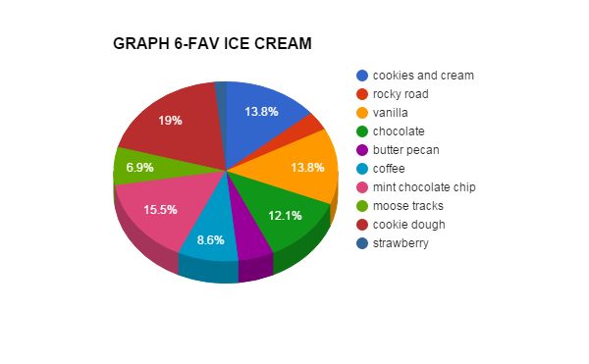
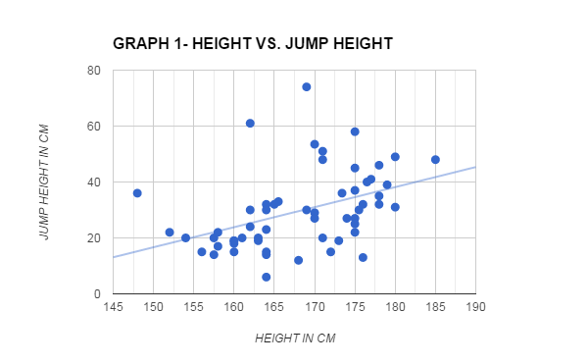
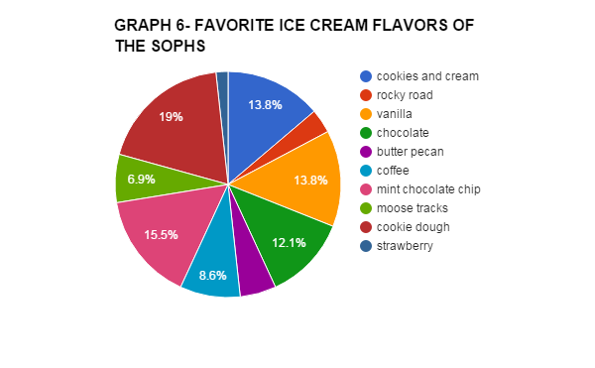
Conclusion: discuss whether data corroborated your hypothesis and why they did or didn’t.

