Ch 5 Review
- What is a population?
- Because individuals in a population usually tend to produce more than one offspring, populations ______________
- As a population reaches its carrying capacity, resources become more scarce. What would increase within the population?
Population Growth Over Time
  - 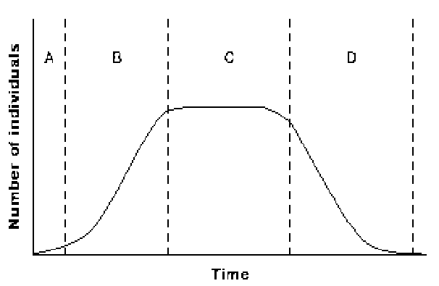
- Which time period shows exponential growth of the population?
- During which time period are the birthrate and death rate equal?
- During which time period will the growth rate of the population be zero?
- The time period during which the rate of growth of a population would have a negative value is
- What are abiotic factors that affect population size?
- Which is a biotic factor that affects population size?
- As the density of a population increases, the effects of starvation and disease also often increase. These are which kind of factors?
- The human population began to grow exponentially during the middle of the 1700s due to the __________________________________
- Vaccines have contributed to human population growth by _____________________________
- Like parasitism, herbivory does not usually result in the _______________________
- What is the predator-prey relationship?
- Over millions of years, plants and their pollinators have __________________________
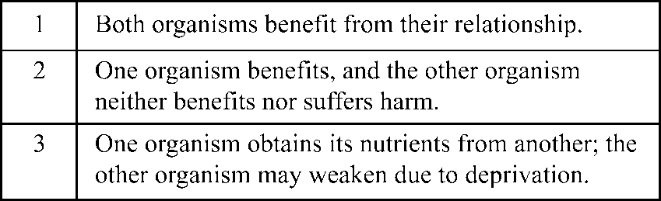
- The table represents three types of _______________________
- The relationship that corresponds to description 2 is known as ______________________
- What is a niche?
- What is the trophic level?
- Which of the following usually results when members of the same species require the same food and space?
- What usually results when members of the same species require the same food and space?
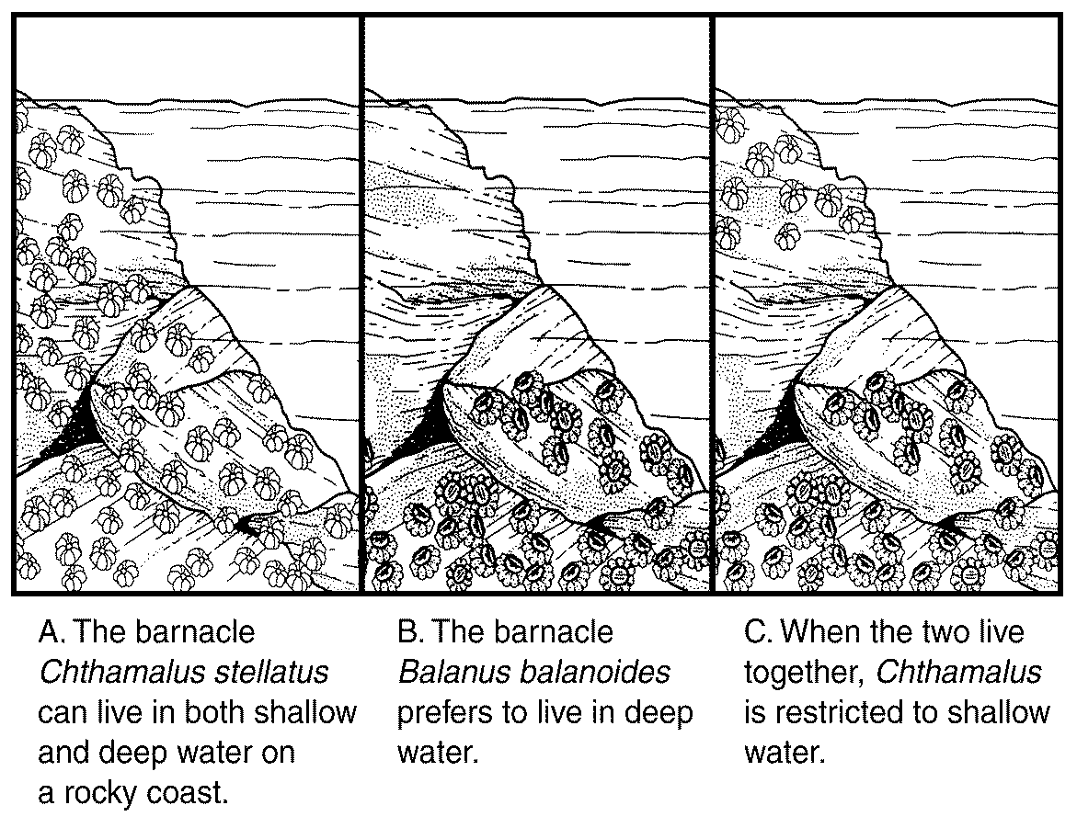
- Because the two species of barnacles attempt to use the same resources, they are __________________________
- What is a competetive niche?
- What is a realized niche?
- What is a fundamental niche?
- If the niches of two organisms overlap, what occurs?
- Sea stars are fierce competitors of marine organisms such as clams and mussels. An ecologist studying an ocean ecosystem performed an experiment in which the sea stars were removed from the ecosystem. After the removal of the sea stars, what would happen to the ecosystem?

