Chapter 8 Review Name__________________________________
- What are phospholipids? _______________________________________________________________________________
- What are channel proteins? _______________________________________________________________________________
- What is active transport? Give three examples of active transport. ________________________
____________________________________________________________________________________________________________________________________________________________________
- Ions move through ion channels by (active / passive) transport.
- Is osmosis active or passive transport? _______________________________________________
- What is an isotonic solution? Hypertonic solution? Hypotonic solution? ______________________________________________________________________________________________________________________________________________________________
- What types of solution cause a cell to burst? Shrink? ______________________________________________________________________________________________________________________________________________________________
- What is the difference between active and passive transport? ______________________________________________________________________________________________________________________________________________________________
- Is the sodium-potassium pump active or passive transport?
- how do large proteins and polysaccharides move through the cell membrane? ______________________________________________________________________________________________________________________________________________________________
- Materials removed from the cell via vesicle is called_____________________
- When a receptor protein is activated outside the cell, what happens? ______________________________________________________________________________________________________________________________________________________________
- What binds to the receptor proteins? _______________________________________________________________________________
- What is this an example of?

_____________________ ________________ ______________________
- Label the above as hypotonic, hypertonic or isotonic. The circle is the cell and each black dot represents a molecule of sodium.
- What portion of the cell membrane is polar? Non-polar? Which one repels water? Attracts water? ______________________________________________________________________________________________________________________________________________________________
- What are the proteins that identify the cell called? _______________________________________________________________________________
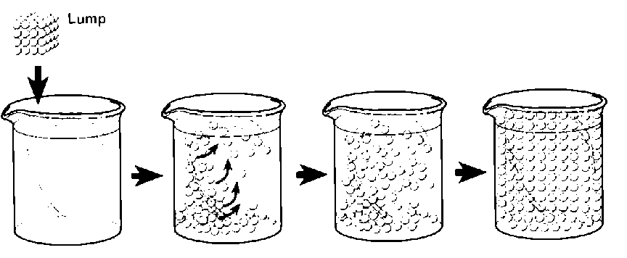
- What is being shown here- the lump could represent sodium or sugar. ______________________
- The movement of a substance from an area of high concentration to low concentration is called__________________________________
- The dispersal of ink in a beaker of water or air freshener in a large room are examples of ______________________________
- What are channel proteins? _______________________________________________________________________________
- What is active transport? Give three examples of active transport. ______________________________________________________________________________________________________________________________________________________________
- Is osmosis active or passive transport?

