Ch 20 Review
- Describe the chromosome of a bacteria.
- Structures found in bacterial cells but not in eukaryotic cells are
- What are the shapes of these?
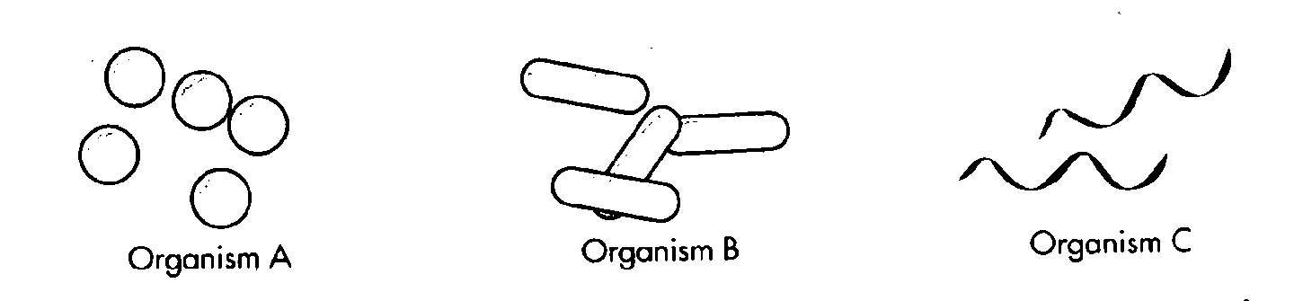
- What are plasmids?
- What are prions?
- Cell organelles that Escherichia coli and other bacteria have in common with eukaryotes are ___________________
- It is important to distinguish between Gram-positive and Gram-negative bacteria in diagnosing a bacterial infection because _______________________________
- What is the difference between eukaryotic and prokaryotic cell walls?
- what make up bacterial cell walls?
- Cyanobacteria are photoautotrophs because they require ___________________________
- What are nitrogen-fixing bacteria?
- What is conjugation?
- What is binary fission?
- What is a bacterial endospore?
- Are viruses alive? Why or why not?
- What are viruses doing in biology?
- What are the parts of a typical virus?
- What types of viruses are there?
- What is an RNA virus?
- What is a DNA virus?
- What is a retrovirus?
- The function of a bacteriophage’s tail and tail fibers is to inject __________________________
- What is a lytic cycle?
- What is the lysogenic cycle?
- What is a virulent virus?
- The cycle of viral infection, replication, and cell destruction is called the virus’s ________________________
- What is a prion?
- What is Koch’s postulate?

