Study Guide Quiz #1

A value is a standard or a belief.
Self-control is the degree to which a person regulates his or her own behavior.
A person who uses self-control to act on responsible values has good character.

Delayed gratification is voluntarily postponing an immediate reward in order to complete a task before enjoying a reward.
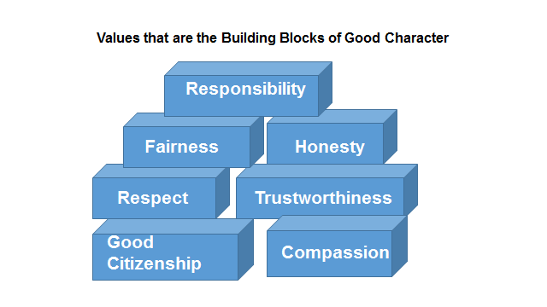
Bigotry is the intolerance of other ethnic, racial, cultural or religious groups.

Bullying is any behavior meant to hurt someone; intentionally and repeatedly using one’s power to hurt others.
Cyberbullying is using computers, cell phones or other electronic means to harass someone.
Gossiping and spreading rumors is saying something to damage someone’s reputation.
Rejection is refusing to acknowledge someone---their presence, their value or their worth.
Relational Aggression is acts that harm others through damage to relationships or feelings of acceptance, friendship or group inclusion.
Sexual harassment is any behavior that is uninvited, unwelcome and unwanted and is sexual in nature, such as writing a sexual comment on a bathroom wall or forcibly trying to kiss someone.
An upstander is someone who stands up to a bully.
A bystander is someone who witnesses bullying but does nothing about it.

What to do if you are being bullied:
- Be strong.
- Stay cool.
- Stand up for yourself.
- Walk away and ignore the teasing.
- Don’t bully back lighten the air.
- Avoid unsafe areas.
- Tell an adult.
- Tell a friend what is happening.
- Make friends.
- Ask the bully to repeat what he or she said.
- Keep a diary of what is happening.
- Don’t blame yourself.

True Statements
Kids who are being victimized by bullies tend to get lower grades.
The damage caused b harassment can last a lifetime.
Former harassers are much more likely to have criminal records than adults who weren’t harassers in their childhood.
The difference between playful teasing and harassment is the person’s intent to be hurtful.
People who are picked on often become harassers themselves.
False Statements
Harassment is no big deal; it’s just kids being kids.
If you are being harassed, it is best to deal with the problem on your own. Do not involve an adult.
When you are being harassed, you should always fight back physically.
Bullying is always physical.
Comments can be considered sexual harassment even if the target welcomes the comments.

Suicidal people do not want to die - they want the pain to go away and they don’t know how to stop it.
You should NEVER remain silent if you think someone is suicidal. It’s better to have a friend that is mad at you than one who is dead. Be telling someone you may save their self and help them get the help they need.

Warning signs of suicide might include:
Giving away belongings, obsession with death, suicide threats, poems, essays and drawings that refer to death, a dramatic change in appearance or personality, irrational or bizarre behavior, an overwhelming sense of guilt, shame or rejection, a change in sleeping or eating patterns, a severe drop in school performance.

Depression is a serious mental illness and should not be taken lightly.
Types of Depression:
Chemical imbalance - changes in brain chemistry - can be born with it or acquire it
Manic depression - also referred to as bipolar disorder - extreme highs and lows

The death of a family member or close friend, divorce, low self-image, breakup with a boyfriend or girlfriend are examples of things that may trigger depression. There are many others.
Treatments - there are several types of treatments. Antidepressants are a medical treatment that will still allow you to be sad if something bad happens but stops you from feeling suicidal. It takes the lows off of depression. Antidepressants should always be used with counseling.

