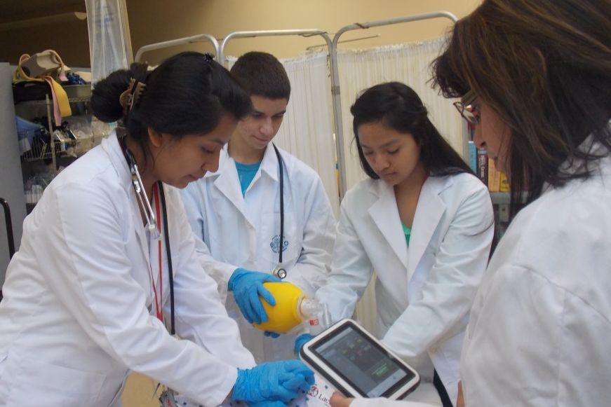 |  | Warren Tech  - Health Sciences  - 2020-21
Go Knights! |  | Health Sciences

WARREN TECH HEALTH SCIENCES
Warren County Technical School’s Health Science Career Academy introduces students to the expansive career paths available in health care. The core curriculum emphasizes science, the human and organizational side of health care, and clinical experience.
The program is designed to prepare students to enter the health care work force and/or further their education that facilitates their higher educational experience. Warren County Technical School partners with Rutgers University to offer successful students the opportunity to earn up to 23 undergraduate credits that can be transferrable to other universities.
Students start with an introduction to health sciences career possibilities and an overview of anatomy and physiology. Students also gain exposure to professionals and real life experiences in the field through required shadowing opportunities.
Students in the program will study medical ethics, medical terminology, medical math, anatomy & physiology, chemistry, and CPR as they prepare for post-secondary opportunities in the field. Courses are taught with the potential to earn college credit in Dynamics of Health in Society, Medical Mathematics, Medical Terminology, Anatomy & Physiology I and II from Rutgers University – The School of Health Professions. These credits can be transferred to a many receiving institutions. Chemistry or Biochemistry is intended to be a required course.
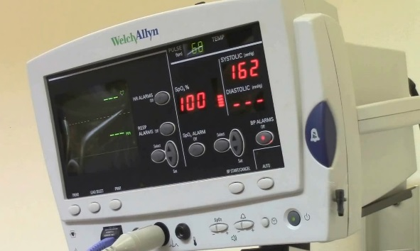
Hands-on Experience with Modern Technology

Students in the Health Sciences program will have the opportunity to utilize modern medical equipment and technology as they explore the field.
College Credit
Students will be afforded the opportunity to earn 17 college credits through Rutgers University and/or 6 credits through Warren County Community College.

Pathways in Health Sciences

Students enrolled in the Warren Tech Health Sciences Shop will receive a rigorous curriculum outlined by Rutgers University, that prepares them with the necessary foundation to launch their future health care endeavors. Students will have the potential of earning a total of 17 undergraduate credits through Rutgers University along with 6 dual-enrollment credits through Warren County Community College (WCCC) which may be transferrable to other health related programs. Students will explore a variety of career paths within the Health Science field and prepare for future professional plans.
College Prep – Four Year Colleges & Universities
Students enrolled in the Health Sciences program at Warren Tech will be prepared for college programs in either health science or science. Students have successfully transferred Rutgers college credits earned and attended other colleges of their choice. Completing a degree at Warren Tech gives students a tremendous advantage as they prepare for degrees in the health care field. Alumni have attended Rutgers School of Pharmacy, Rutgers School of Arts and Science, Stevens Institute of Technology, Moravian College, Messiah University, St. Peter’s University, Miami University, Kean University, US Navy, Penn State, William Patterson College, Northampton College, St Elizabeth College, and many more.

Two Year Degrees/Post-Secondary Licensing Programs
Health Sciences students in this path have the option of continuing their education at two year schools such as WCCC, where they can pursue an Associate’s Degree and licensing as a Registered Nurse or Medical Assistant. Students might also choose to continue in the Allied Health Programs at WCCC. Students also have the opportunity to continue their education at Warren Tech’s Adult Education Post-Secondary School with automatic enrollment where they can complete their degree as a Licensed Practical Nurse (LPN). Some past alumni have proceeded to Raritan Valley, Warren County, County College of Morris, Sussex County, and other community colleges for degrees and certificates.

Clinical Experiences
Students gain exposure to professionals in the field and real-life experiences through field trips, clinical, guest speakers, and shadowing opportunities.
Warren Tech
Health Sciences
“I can never thank Warren Tech’s Health Science program enough for everything they gave me beyond that of an extraordinary education.”
K. Seals, ‘16

For More Information Contact: Warren Tech Admissions
admissions@wctech.org
908-835-2819

