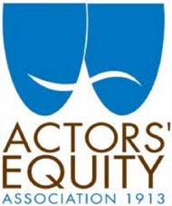
Actors' Equity Association ("AEA" or "Equity"), founded in 1913, is the labor union that represents more than 49,000 Actors and Stage Managers in the United States. Equity seeks to advance, promote and foster the art of live theatre as an essential component of our society. Equity negotiates wages and working conditions and provides a wide range of benefits, including health and pension plans, for its members. Actors' Equity is a member of the AFL-CIO, and is affiliated with FIA, an international organization of performing arts unions.
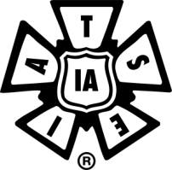
The International Alliance of Theatrical Stage Employees, Moving Picture Technicians, Artists and Allied Crafts of the United States, Its Territories and Canada, was founded in 1893. Today the IATSE is the largest union representing workers in the entertainment industry. Their members work in all forms of live theater, motion picture and television production, trade shows and exhibitions, television broadcasting, and concerts, as well as the equipment and construction shops that support all these areas of the entertainment industry. They represent virtually all the behind the scenes workers in crafts ranging from motion picture animator to theater usher.
Local One represents the IATSE stagehands of New York City. They construct, install, maintain, and operate the lighting and sound equipment, scenery, and special effects of productions and concerts on Broadway, at Radio City Music Hall, Madison Square Garden, Carnegie Hall, and the Metropolitan Opera as well as television broadcasts from CBS, NBC, ABC, FOX, and PBS.
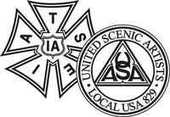
Local 764, the Theatrical Wardrobe Union, has over 1,200 members working in all aspects of costume and wardrobe work in the NYC area in virtually every major live entertainment venue in the city, as well as on television shows and motion pictures shooting within a 50-mile radius of Columbus Circle. First organized in 1919, they became a local of IATSE in 1942.
United Scenic Artists, Local USA 829, is a labor union and professional association of designers, artists, and craftspeople organized to protect craft standards, working conditions, and wages for the entertainment and decorative arts industries. The members of Local USA 829 are artists and designers working in film, theatre, opera, ballet, television, industrial shows, commercials and exhibitions. The current active membership totals nearly 3,800.
Established in 1928, ATPAM members are press agents, publicity and marketing specialists, company managers, and house and facilities managers. In 1994, ATPAM affiliated with IATSE as Local 18032.

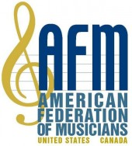
Founded in 1896, the American Federation of Musicians of the United States and Canada is the largest organization in the world representing the interests of professional musicians. AFM is committed to raising industry standards and placing the professional musician in the foreground of the cultural landscape.

Established in 1921, the Associated Musicians of Greater New York, American Federation of Musicians Local 802, is one of the largest local unions of professional musicians in the world. All pit musicians for Broadway shows are members of AFM Local 802.
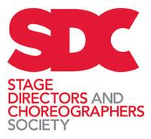

Founded in 1959, and formerly known as the Society of Stage Directors and Choreographers (SSDC), SDC represents exactly what its name states, stage directors and choreographers working in the United States.

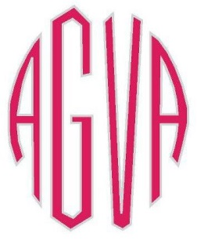
The American Guild of Variety Artists (AGVA) is an AFL-CIO affiliated labor union founded in 1939 to represent performing artists and stage managers for live performances in the variety field. The variety area of performance includes singers & dancers in touring shows and in theatrical revues (non-book shows – book revues may be under Actors’ Equity jurisdiction), theme park performers, skaters, circus performers, comedians & stand-up comics, cabaret & club artists, lecturers/poets/monologists/spokespersons, and variety performers working at private parties & special events. Performers appear under AGVA contracts at Radio City Music Hall and around the world in various Radio City Spectaculars starring the Rockettes, at theme parks such as Disneyland, Universal Studios & Magic Mountain, and in hundreds of revues in New York and across the country (including such regularly-produced favorites as Beehive, Sugar Babies, Swing, Our Sinatra, NEWSical, Ring of Fire, Watercoolers, Dame Edna, and others).

The Casting Society of America (CSA) was created in February of 1982 with the intent of establishing a recognized standard of professionalism in the casting field and providing its members with a support organization to further their goals and protect their common interests. CSA is not a union. It is a professional organization open to all Casting Directors and Casting Associates.

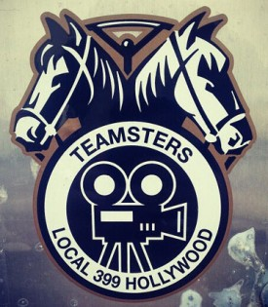
Unionized Casting Directors and Casting Associates are organized under Teamster local 399 in Los Angeles and local 817 in New York. CSA and the Teamsters are two separate organizations and, while cooperative, do not have the same functions in the professional lives of Casting Directors and Associates.

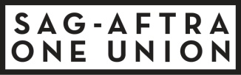 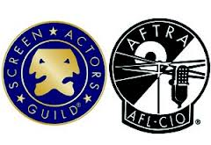 http://www.sagaftra.org

Formerly two separate unions, Screen Actors Guild and the American Federation of Television and Radio Artists finally merged in 2012 after three previous attempts that did not garner enough member votes within both unions.

SAG-AFTRA represents more than 160,000 actors, announcers, broadcasters, journalists, dancers, DJs, news writers, news editors, program hosts, puppeteers, recording artists, singers, stunt performers, voiceover artists and other media professionals.

1933 – SAG is founded to represent performers appearing in motion pictures.

1935 – Radio Actors Guild in Los Angeles, and Radio Equity (a radio division of AEA) in NYC are founded.

1937 – AFTRA’s predecessor, AFRA (American Federation of Radio Artists) is founded replacing the short-lived Radio Actors Guild and Radio Equity.

As the new technology of television gains popularity, a jurisdiction dispute arises over who will represent television performers.

1950 – The Associated Actors and Artistes of America [see below] creates the Television Authority which negotiates the first network television contract.
1951 – AFRA negotiates the first Phonograph Recording Code for singers with the major recording labels.
1952 – The Television Authority and AFRA merge to create a new union: the American Federation of Television and Radio Artists (AFTRA)
The Associated Actors and Artistes of America (4As) is the federation of trade unions for performing artists in the United States. It was founded in 1919 as an umbrella organization composed of nine autonomous performing arts unions. The main purpose of the Four A's since its founding has been to represent the affiliates' common interests and to resolve jurisdictional disputes.
- AEA covers actors and stage managers performing in plays, musicals and revues on the legitimate stage.
- SAG-AFTRA covers performers in film, television, radio, and digital media.
- The American Guild of Musical Artists (AGMA) covers opera, dance and concert performances.
- The American Guild of Variety Artists (AGVA) covers nightclubs, arena shows and ice shows.
[Note: Disney World in Florida has a contract AEA; Disneyland in California has a contract with AGVA.]
The 4As supports the decisions of its sister unions and offers a collective voice for performing artist labor issues.

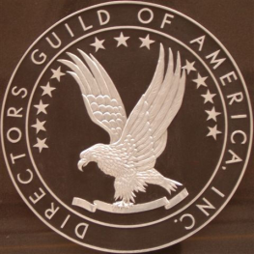
Founded in 1936, the Directors Guild of America (DGA) is a labor organization that represents the creative and economic rights of directors and members of the directorial team working in film, television, commercials, documentaries, news, sports, and new media.
The Writers Guild of America (WGA) is a generic term referring to the joint efforts of two different labor unions:
- The Writers Guild of America, East (WGAE), representing TV and film writers east of the Mississippi River.
- The Writers Guild of America, West (WGAW), representing TV and film writers in Hollywood and southern California.
The WGAW represents writers in the motion picture, broadcast, cable, and new media industries.

