Ellipsoidal Reflector Spotlight
The most common focusable unit used in the theatre today is the ellipsoidal reflector spotlight (ERS, or in theatrical slang, "leko"). The ERS produces a round (conical), well-defined beam of light.
Because of the precise light control possible with the ERS, these units, assuming the appropriate beam spread is chosen, are effective from any position in the theatre.
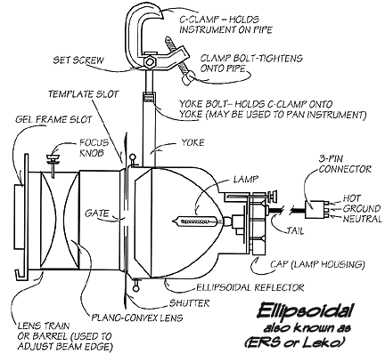
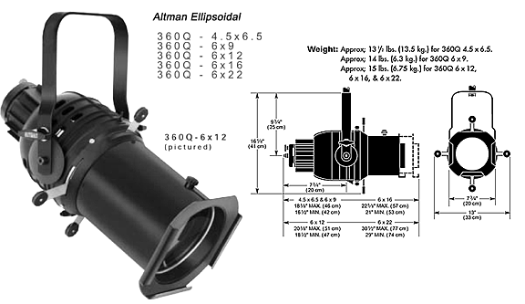
The Fresnel
A lightweight, short throw, all-purpose lighting device, the 6" Fresnel produces a soft-edged beam. It is used in theatre for acting area lighting where beam shaping is not required or in television studios for key and backlighting.
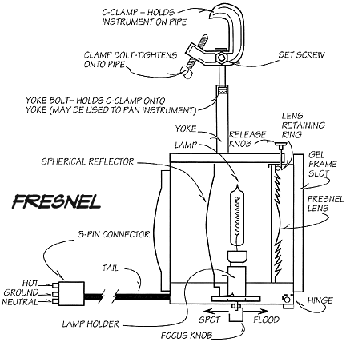
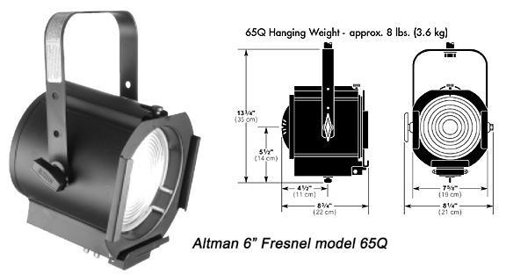

PAR (Parabolic Aluminized Reflector)
The PAR Can is a low cost, versatile lighting instrument designed for diverse applications. One unit can serve multiple purposes simply by changing the lamp. The PAR Can has an oval shaped beam.
