Review for Unit 1.3
- Organisms rely on both negative feedback processes and behavior to maintain __________.
- What is homeostasis and how does it impact biological themes?
- what processes enables cells to stay within the limited range of conditions in which they function best?
- Internal control systems maintain homeostasis by regulating which of these?
- what is thermoregulation? What are some symptoms of failure to maintain thermoregulation in humans?
- How does the liver help to regulate glucose levels in the blood? Explain what hormones do what.

- Draw a diagram for regulating blood glucose levels
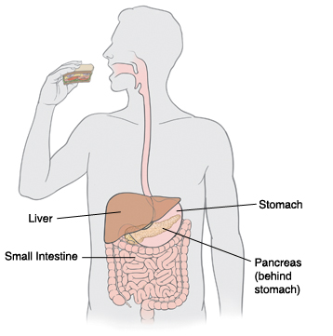
- The body works to maintain homeostasis in response to what conditions?
- Name three reasons that are most important for an organism to maintain homeostasis?

- The body’s internal environment must stay __________.

- The long-term effects of a disruption of homeostasis include damage to what organs- (use diabetes and Cushings to explain this)
- what factors alter the rate of photosynthesis
- what is the pituitary gland and what hormones does it release? (6)
- what is the adrenal gland and what hormones does it release? (3)
- what is the pancreas and what hormones does it release?
- what is the thyroid gland and what hormones does it release?
- what is the definition of negative feedback response and give three examples

- what is the definition of positive feedback response and give three examples

