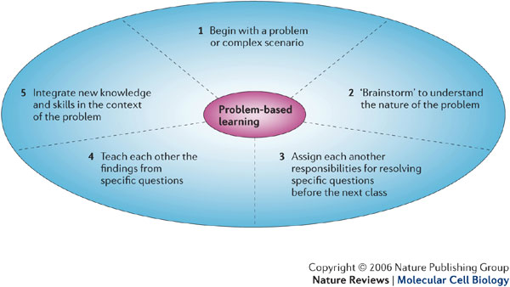

Short Cut to Problem-Based Learning:

This is a simplified model. Note that it is an iterative model. Steps two through five may be conducted concurrently as new information becomes available and redefines the problem. Step six may occur more than once--especially when teachers place emphasis on going beyond "the first draft."
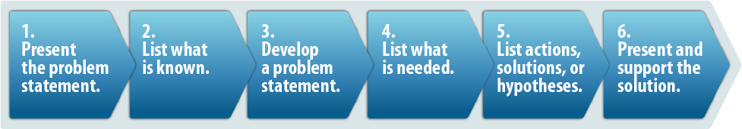
Present the problem statement.
Introduce an "ill-structured" problem or scenario to students. They should not have enough prior knowledge to solve the problem. This simply means they will have to gather necessary information or learn new concepts, principles, or skills as they engage in the problem-solving process.
List what is known.
Student groups list what they know about the scenario. This information is kept under the heading: "What do we know?" This may include data from the situation as well as information based on prior knowledge.
Develop a problem statement.
A problem statement should come from the students' analysis of what they know. The problem statement will probably have to be refined as new information is discovered and brought to bear on the situation.
List what is needed.
Presented with a problem, students will need to find information to fill in missing gaps. A second list is prepared under the heading: "What do we need to know?" These questions will guide searches that may take place on-line, in the library, and in other out-of-class searches.
List possible actions, recommendations, solutions, or hypotheses.
Under the heading: "What should we do?" students list actions to be taken (e.g., questioning an expert), and formulate and test tentative hypotheses.
Present and support the solution.
As part of closure, teachers may require students to communicate, orally and/or in writing, their findings and recommendations. The product should include the problem statement, questions, data gathered, analysis of data, and support for solutions or recommendations based on the data analysis.
Students are encouraged to share their findings on-line with teachers and students in other schools, within the district, region, state, nation, or internationally. Teachers will find that students pay more attention to quality when they have to present or show their written products to students in other schools.

Review of research:

Research findings suggest:
- Some evidence suggests that PBL curricula may enhance both transfer of concepts to new problems and integration of basic science concepts into clinical problems.

- PBL enhances intrinsic interest in the subject matter.

- PBL appears to enhance self-directed learning skills (metacognition), and this enhancement may be maintained (Norman & Schmidt).

Goals of PBL:

PBL is used to engage students in learning. This is based on several theories in cognitive theory. Two prominent ones are that students more willingly work on problems perceived as meaningful or relevant and that people try to fill in the gaps when presented with a situation they do not readily understand. Teachers present students with a problem set, then student work-groups analyze the problem, research, discuss, analyze, and produce tentative explanations, solutions, or recommendations. It is essential to PBL that students do not possess sufficient prior knowledge to address the problem. In the initial discussion, students develop a set of questions that need to be addressed. These questions then become the objectives for students' learning.
Norman and Schmidt (1992) state there are three roles for PBL. The first is the acquisition of factual knowledge, the second is the mastery of general principles or concepts that can be transferred to solve similar problems, and third, the acquisition of prior examples that can be used in future problem-solving situations of a similar nature.

Resources for Learning:

The Global Climate Change PBL materials include enough information to get the students started with the problem scenario they are to explore. Background information is provided, but we have purposely avoided duplicating everything available about a given subject. Within the World Wide Web is a seemingly infinite amount of information. In some cases, the module points students to additional areas. Often, students will have to conduct Internet searches to find materials. Teachers should avoid having a group of three to five students rely only on electronic or on-line materials. Students must be encouraged to divide the work through a delegation of tasks. Some students may be working on a computer while others are finding or using written references, or using other audiovisual aids.
Problems in Implementing Problem-Based Learning in the classroom:

Students
Students familiar with the traditional "talk and chalk" classroom are likely to be uncomfortable with the PBL format for some time, although PBL strategies are becoming increasingly used in classrooms. It will be up to the teacher to convince students that they are researchers looking for information and solutions to problems that may not have one "right answer." Some likely problems include students wanting to know exactly what they have to do to get their grade and students expecting the teacher to assign a number of tasks, events, concepts, and a set "number of pages" for written products.
Those students adept at "book learning" may feel uncomfortable in PBL roles in which they have to conduct research, coordinate with peers, and generate unique products. These students' parents may express some concern when their son or daughter isn't comfortable with this new environment.

Teachers
Teachers unfamiliar with PBL are in for some surprises. Moving into "untraditional" instructional modes may appear risky, scary, and uncertain. The good news is that this environment is exhilarating, meaningful, and rewarding. It may turn out to be one of the most exciting things teachers and students have experienced.

Relevance
Look for windows into students' thinking in order to pose problems of increasing relevance. Students who have participated in other Exploring the Environment modules report a high degree of relevance and connection to the subject matter.

Challenge
The problem scenario should challenge students' original hypotheses. We have tried to make the Global Climate Change modules engaging; don't hesitate to elaborate upon the scenario to engage students.

Time
Students must be given time and stimulation to seek relevance and the opportunity to reveal their points of view.

Ownership
If the teacher appears to be heading students in a particular direction, they'll see that this really isn't their problem after all. They'll see that there is a correct solution and that it belongs to the teacher.

Complexity
Teachers new to the PBL classroom may be tempted to give students key variables, too much information, or problem simplification. Complexity of scenarios has been shown to increase student motivation and engagement.

Second questions
Asking students to elaborate sends the message that the teacher wants to know what the student thinks and why. Brooks and Brooks (1993) state that "awareness of students' points of view is an instructional entry point that sits at the gateway of personalized education...teachers who operate without awareness of their students' points of view often doom students to dull, irrelevant experiences, and even failure

Note
Questioning Techniques. In a PBL classroom, teachers should act as metacognitive coaches, serving as models, thinking aloud with students and practicing behavior they want their students to use (Stephen and Gallagher, 1993). Students should become used to such metacognitive questions such as: What is going on here? What do we need to know more about? What did we do during the problem that was effective? Teachers coax and prompt students to use questions and take responsibility for the problem. Over a period of time, students become self-directed learners and teachers can then provide less scaffolding, fading into the background (Stephen and Gallagher, 1993).

Summary
Our project delivers a science education package designed to increase climate literacy among middle school students in science classes and high school students in environmental, ecology, or integrated science classes with a unit on environmental issues. The project also seeks to increase the knowledge and understanding of Earth’s climate mechanisms and the complexities of today’s global sustainability. Online curricular materials teach climate literacy in a highly engaging, student-centered approach.
Research indicates that changes in science classroom methodology can lead to increased student understanding of critical issues. Our goal is to engage and motivate students to explore and understand issues in depth. The challenge is to provide teachers with alternative approaches to teaching and learning that will achieve this goal. Problem-based learning is one of these alternatives.
Teachers' roles are an essential ingredient to effective use of PBL in the teaching-learning scenario. We have presented information for teachers to use in helping students engage in learning and to reach new levels of understanding using problem-based learning.
Adapted from: Center for Educational Technologies (Classroom of the Future), Exploring the Environment http://www.cotf.edu/ete/

