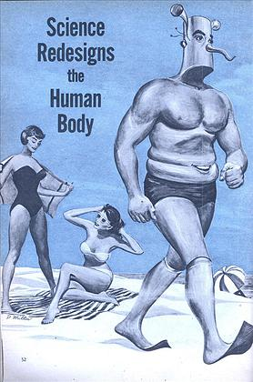
On a golf course last fall, a New York accountant took a healthy swing at the ball, fell to the ground and couldn’t get up. He spent the next nine weeks in a hospital. Slipped spinal disc.
A mailman in Philadelphia was forced to turn in his resignation when fallen arches made walking unbearable.
In Chicago, an office worker running for a bus suddenly crumpled to the ground. He hobbled to a stoop and sat until help arrived. Dislocated knee, the doctor said.

Multiply each of these instances by several million and you will get a rough idea of the number of bad backs, sore feet and trick knees which abound in this country alone. It all adds up to the fact that, while the human body has never been equalled from the standpoint of all-around master engineering, a number of glaring weaknesses do exist in man’s basic equipment.

How would scientists go about redesigning the human creature in order to get the most efficiency out of him?

You may pick groups of three to four to redesign a body part, organ, or body system with the goal of being awarded a patent for their design. Each team’s design is judged by a team of “patent judges” who determine the winning design. You will create a powerpoint to accomplish this.
Each group must first
- research and complete the sheet for each of the following systems
- Cardiovascular
- Digestive
- Muscular
- Nervous
- Respiratory
- Skeletal
- Excretory
- Immune
Use the following to help

https://www.youtube.com/watch?v=qhajGKS5thQ
https://www.youtube.com/watch?v=thPbvQOAz6g
http://www.livescience.com/37009-human-body.html
https://www.youtube.com/watch?v=nnjmrrQ6xOs
http://www.innerbody.com/

DUE__________________________________________

- identify and describe in writing the morphological and anatomical structure and the mechanical and physiological function of your team’s selected system and its main organs and parts

DUE ____________________________________________

Additionally, students are then asked to create a presentation to give to the patent judges that showcases their redesign. It should
- identify the part, organ, or whole body system to study and re-design,
- develop a convincing argument that their re-design is better and more efficient for achieving its main intended functional purpose.
- Describe the design including the materials/structures that will replace the original current design and how they could be obtained and/or housed and supported
- explain how it would impact the other systems and what possible modifications might be necessary for compatability

DUE ______________________________________________________________________

